**Purpose**

For the assignment, an initial stock analysis was conducted for Steve. We refactored the original code and the purpose was to determine if the refactored changes made an impact on the run time. Using the run button created, Steve can run analysis for the preferred year by inputting it in the input box. The code after running the analysis also uses a timer to show Steve how long it takes for the analysis to run.

## Comparing 2017 and 2018 Stock Analysis

Comparing the 2017 and the 2018 stocks, most of the stocks were unable to generate a positive outcome for the year 2018. The tickers ENPH and RUN had would have been considered good investments due to the positive returns in 2018. In 2017, TERP was the only stock that had a negative outcome. Highest return was generated by DQ in 2017 followed by SEDG and ENPH and these would have been considered the best investments for the year 2017. The overall difference of the total daily volume between both years is over $100,000,000.

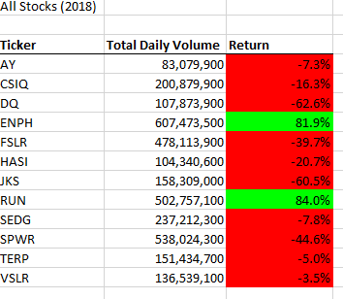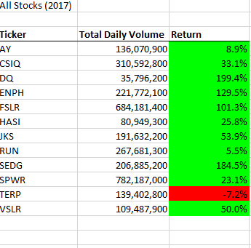

## Comparing the Run Times

Refactored script run times for both the years showed that the script took less time to run and show results. For example, As shown in the pictures below, original script for year 2017 took around 4s. While the refactored script ran quicker. This shows that by refactoring the code we optimize it.

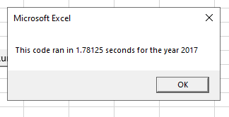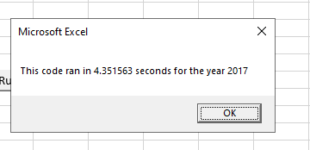

# **Summary**

## 1. What are the advantages or disadvantages of refactoring code?

The advantages of refactoring code are:

* A programmer can catch repeated subroutines, unnecessary loops, or code that was accidently left in the script.
* Improves the design
* Helps programming run faster

The disadvantages of refactoring code include:

* Refracting a stable code could be expensive or present new bugs into the system.
* Many programmers are working under tight deadlines, refactoring can be time consuming.

## 2. How do these pros and cons apply to refactoring the original VBA script?

By refactoring the original VBA script, we can keep the code well-organized and in turn it makes it always easy to change, easy to comprehend, and easy to sustain. It can decrease the memory required for processing the data, which reduces the run time and optimizes the performance of the script. To refactor the code, with each new addition testing must be done to check for the efficiency of the new code.